Looking for the best model to study characteristics of people that impact the Self-Transcendence dimension in the Human Value scale for two rounds of the European Social Survey.

**Pamela Isabel Inostroza Fernández**

Master in Statistics, KU Leuven, Belgium

# Abstract

Many studies have been conducted the last years concerning the construction of a scale that measures Human values. This paper uses this scale to search for different behaviour in specific groups, identified with similar background characteristics. Universalism and Benevolence subscales are studied, these two constructs can be aggregated in one global construct, called Self-Transcendence, using a second-order model. Sociodemographic characteristics are used as exogenous variables to identify a relation between them and the latent variables. Variables as age, gender, educational level, Domicile and Human Development Index are examined. In this paper is evaluated not only CFA with their respective Multigroup Analysis but also Structural Equation Model (SEM), Multiple indicator Multiple cause models (MIMIC) and Multilevel Structural Equation (MLSEM). The measurement model was conducted using each methodology, fit measurements values suggest a good fit in all of them. Given that for nested data is usually more difficult to obtain invariance of the parameters, partial scalar invariance was obtained, setting free two parameters of the model. The full structural equation model including covariates can be separated into one-level models and two-level models, the first ones include a SEM and a MIMIC model, these held also good fit measures. Multilevel models included a two-level SEM and a two-level MIMIC, both models had poor fit measures influenced by the lack of isomorphism found, as in level 2 the measurement model is not the best. Variables analysed differ in the effect introduced into each subscale (Benevolence and Universalism), where Gender, Education level (with different strength) and Human Development Index remain significant factors. This allows that the second-order construct Self-Transcendence present the same factors as well. Domicile variable is only significant for the Universalism subscale, for this reason, is not significant in the second-order latent variable. Age present contrary results in both subscales, although not a strong relation, estimates are negative for Benevolence but positives or null for Universalism, this way Self-Transcendence dispense this factor. In conclusion, MIMIC model allows getting more detail information considering all subscales and exogenous variables, although Multilevel allows separating the information in two-level it is important in the future to study which structural model would be the correct one to use in level 2 accordingly to the literature.

# Research question

During crisis period, like the one our society worldwide is living these days due to pandemic caused by Covid-19, people show the best of themselves, helping the neighbour by making their life easier or at least having the consideration for the others just by staying at home. However, is also known that there are people that only think about themselves, like to get all the cleaning products from the supermarket and creating lack of essential goods for the rest or increasing the prices of basic products. Since the government is constantly implementing new strategies to avoid the extension of the pandemic through more social conscience to move on into the "new" normality, it would be interesting to search for specific target groups to focus the political practices. The goal of this study is to analyse if there are some sociodemographic characteristics that describe people with more or less indicator of the human values scale in European countries.

Many researches have been studied how to assess Human Values scales through different methodologies for earlier rounds of the European Social Survey. In this study, a summary of differences in using each methodology to obtain a valid measure of the scale will be provided. Additionally, a model examining possible differences on the scale for sociodemographic characteristics would be studied, comparing effects on the scale. It should be established that is not the task of this paper to examine the composition of the human value construct, the methodology for this can be found in (Schwartz and Boehnke 2004) in detail.

To accomplish the objective of this research, the last two rounds of the human value scale from the European Social Survey (ESS) will be utilised considering its data characteristics, such as weights and nested levels. Firstly, confirmation that the structure of the scale remains the same as stated for previous rounds of the survey using information from participating countries will be checked through Confirmatory Factor Analysis (CFA). Secondly, the scale (or part of it) will be used to draw a Structural Equation Model (SEM) and a Multiple indicator Multiple cause model (MIMIC) using as predictors some background characteristics variables collected in the survey. Finally, the results obtained will be validate considering the country level as a hierarchical model, this will be done by Multilevel Structural Equation Model (MLSEM).

# Description of the dataset

# The European Survey (ESS) is a survey administered in over 35 countries to date. The objective of this survey is to monitor and interpret changing public attitudes, improve methodologies for cross-national survey measurement in Europe and to develop a series of European social indicators. Two last rounds of the survey, 8th round was implemented in 2016 and 9th round in 2018, will be used including 14 countries that participate in both rounds.

Data consists in around 2000 observations by country, the description for each sample size by country and round is in Table 5 in the Appendix. The survey design was done using random probability sampling; therefore, each observation contains a design weight to correct for unequal probabilities for selection, these weights are scaled in a way that the sum of the final weight equals the sample size. The survey was responded by persons aged 15 and over, resident within private households, regardless of their nationality, citizenship, language or legal status (European Social Survey 2018).

The European Social Survey data [1] (European Social Survey Round 9 Data. 2018; European Social Survey Round 8 Data. 2016) include the human value scale in their periodical study. The theoretical proposal, evaluation and validation of the model that measures the Human Value scale was stated for the ES Survey by (Schwartz 2003). In that document the methodology suggests which items should be used in order to obtain a Human Value scale, this scale is composed by 10 basic values: Power, Achievement, Hedonism, Stimulation, Self-direction, Tradition, Conformity, Security, Universalism and Benevolence.

The list of values mentioned before can be summarized in 4 dimensions (Figure 1), Openness to change, Self-Enhancement, Conservation and Self-Transcendence. This study will be focused on the last dimension of **Self-Transcendence**. This dimension is composed by Universalism and Benevolence, values that involve concern for the welfare and interests of others. A more detail explanation of each of these values can be found in Table 4 in the Appendix.

A definition of the subscales can be summarized as follow:

* **UNIVERSALISM:** Understanding, appreciation, tolerance, and protection for the welfare of all people and for nature. (broadminded, wisdom, social justice, equality, a world at peace, a world of beauty, unity with nature, protecting the environment).
* **BENEVOLENCE:** Preservation and enhancement of the welfare of people with whom one is in frequent personal contact. (helpful, honest, forgiving, loyal, responsible)

Figure 1: Theoretical model of relations among ten motivational types of values. Source: (Schwartz 2003)

In order to obtain more readable results, the scale was inverted. This way, higher the number of the latent variable, higher the presence of the Self-Transcendence value. Since this paper attempts to find if any relation between a sociodemographic background shows different behaviour regarding human values, individual characteristics as Age, Gender, Educational level, and Domicile, and grouped variables as index related to country well-being are studied. These individual variables are available in the survey and are suggested by different research to be influential to this dimension (Inglehart, R., n.d.; Schwartz, S.H., n.d.; Glen, N. D. 1974).

As people grow older and enter families of procreation and attain stable positions in the occupational world, they tend to become less preoccupied with their own strivings and more concerned with the welfare of others (Veroff, Reuman, and Feld 1984). This hypothesis suggests that there is a positive correlation for Age with Self-Transcendence values.

The same relation should be obtained by educational experiences as they promote intellectual openness, flexibility, and depth perspective for self-direction values (Kohn and Schooler 1983). Role learning, cultural feminism and evolutionary theories of gender hypothesise that females are suspected to be more correlate positively with expressive-communal values like benevolence (Prince-Gibson and Schwartz 1998).

While today's crisis solution is focused on social distancing, which is more difficult to achieve in crowded places, the location where people live will be included in the study to investigate if people from bigger cities or countryside have more or less indicator in the human value scale.

Regarding the country level, it is hypothesized that cross-country variations may be accounted for by country differences in economic and technological development (Inglehart 1997). (Coleman 1990) states that environmental protection is expected to be perceived as more important in less developed countries than in postmodern, advanced industrial countries. To research this theory and to measure the level of economic development of the countries, the Human Development Index (HDI) [2] will be used.

# Analysis

# Four different techniques will be compared in this section, the most common methodologies used are the Confirmatory Factor Analysis and Structural Equation Model, both will be compared considering variables as continuous normally distributed and whether taking into account the nested origin of the data or not.

The objective of Confirmatory Factor Analysis (CFA) is to obtain estimates for each parameter of the measurement model (i. e. factor loadings, factor variances and covariances, error variances and error covariances) that produce a predicted variance-covariance matrix that resembles the sample variance-covariance matrix as closely as possible (Brown 2006). In this research, the best approximation is searched in order to obtain the best model fit to be used in the regression.

The analysis is based on the assumption that the sample size is large (asymptotically), that the indicators have been measured on continuous scales (i. e., approximate interval-level data); and that the distribution of the indicators is multivariate normal. For this reason, Maximum likelihood (ML) estimator would be selected, along with *lavaan* package (Daniel Oberski 2016) on R that consider also robust standard errors and a robust (scaled) test statistic.

For cross-cultural analysis, it is established by the specialists that a necessary step is to test invariance. This research wants to confirm that there is no invariance among the countries studied. Typically, the next four levels of invariance are checked: configural, metric, scalar and strict through Multiple Group Confirmatory Factor Analysis (MGCFA). Configural invariance is the lowest level of invariance and it indicates that the same items load on the same latent variables across groups. Metric invariance indicates that the factor loadings of the indicators are equal, if this occurs it implies that the latent variable has equal scale intervals over countries, this allows a meaningful comparison of relationships between latent construct and other concepts across groups (Steenkamp and Baumgartner 1998). In fact, if the goal of the analysis is to compare means across groups, it is necessary to achieve a higher level of invariance, scalar invariance, this additionally requires that the intercepts of each indicator are identical across groups (Davidov et al. 2014). Strict invariance includes not only that intercepts are equal across groups but the residual variances. Thus, a meaningful mean comparison across groups require the first three levels of invariance to be accomplished.

Multiple indicator Multiple cause models (MIMIC) are used when various latent variables are regressed on various manifest predictors. MIMIC model allows the simultaneous estimation of two response latent factors in relation to explanatory variables. It also permits the evaluation of each indicator variables as well as the correlation between factors, while controlling for all the covariates in the model.

Multilevel Structural Equation Modelling (MLSEM) similar to the standard Multilevel Modelling (MLM) considers the hierarchical structure of the data, in this case, individuals nested in countries. This methodology also incorporates the measurement of latent constructs (Meuleman 2019). Therefore, test the extent to which relationships between individual-level variables can be generalized across countries. MLSEM decomposes the variability of the indicators into individual (in this case, within countries) and contextual (between countries) variability.

## Measurement model

The first model used is a Confirmatory Factor Analysis (CFA) where the measurement model provided by the theory is the one defined. The methodology was done according to the procedure of (Brown 2006). Is stated that the Goodness of fit defined by (Brown 2006) consider that fit measures should be under (or above) certain level, these limits are RMSEA (≤ .06, 90% CI ≤ .06), SRMR (≤ .08), CFI (≥ .95), and TLI (≥ .95).

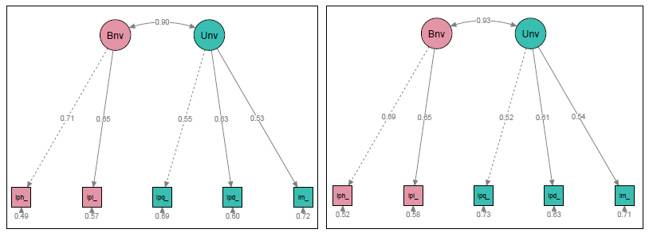

Figure 2: Confirmatory Factor Analysis Self-Transcendence dimension, Benevolence and Universalism scales, round 8 (left) and round 9 (right)

At least metric invariance of the model is necessary to compare regression coefficients if this is not possible, partial equivalence can apply. After stating the confirmation of the theory behind the Self-Transcendence dimension, it is possible to implement a SEM model in order to investigate if the relationships behind this study are there.

## Full Structural Equation Model

In view of the high correlation among the latent variables ($ρ=0.9$) it is possible to produce a common latent variable among our latent variables Benevolence and Universalism to which associate the predictors under study, this model is called a Second-Order Model. The model used is shown in Figure 3, latent variable Self-Transcendence (*STr*) has 4 regressors with their respective categories, Female Gender (*gnD*), Educational level *(es)* [1-“Less than Upper secondary”, 2-“Upper secondary or vocational”, 3-“Bachelor or higher”] and Domicile (*dm*) [1-“Countryside”, 2-“Town or small city”, 3- “Suburbs or outskirts of big city”, 4-“A big city”]. Age (*age*) and the Human Development Index (*HDI*) are considered as continuous variables.

The same regressors were used in the MIMIC model, where exogenous variables regressed both individual latent variables Benevolence and Universalism (Figure 4).

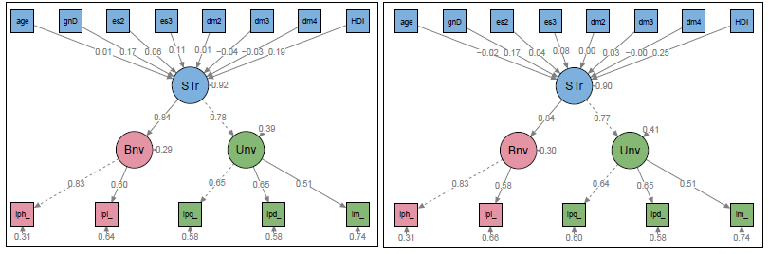

Figure 3: Second order Structural Equation Model with regressors on latent variable Self-Transcendence, round 8 (left) and round 9 (right)

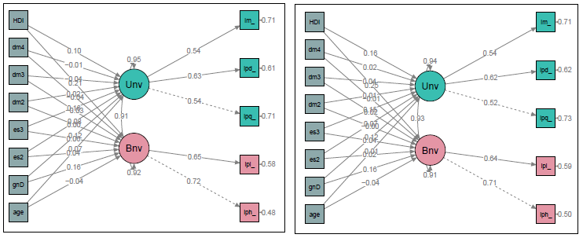

Figure 4: MIMIC model with regressors in latent variables Benevolence and Universalism, round 8 (above) and round 9 (below)

## Multilevel Structural Equation Model

When invariance is not possible, as stated by (Davidov et al. 2012) multilevel modelling is the solution to take into account the differences among clustered data, countries in our case. For this reason, a Multilevel Confirmatory Factor Analysis was conducted in order to check if the structure still is valid for our model considering countries as the higher level. In this model, individual variables as Gender, Age, Educational level, and Domicile would be included in the lowest level as regressors meanwhile Human Development Index would be included as a highest level regressor.

Another advantage of Multilevel modelling is the possibility to evaluate if the same measurement model is appropriate in all levels. Isomorphism implies in concrete terms that the associations between indicators and latent constructs at the individual level (thus within countries) are similar to the associations between indicators and latent constructs at the country level (i. e., between countries) (Meuleman 2019). Same models described previously are employed using multilevel models, CFA (Figure 5), SEM (Figure 6), MIMIC (Figure 7)[3].

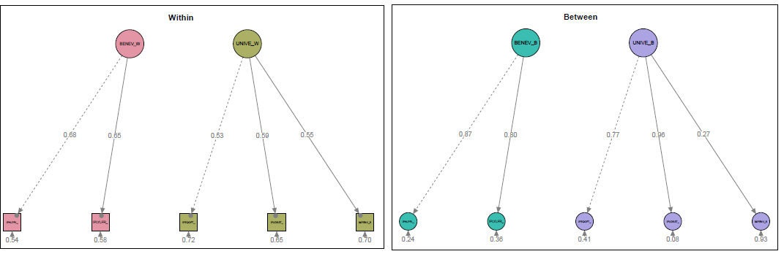

Figure 5: Measurement model using Multilevel modelling (SEM), round 8.

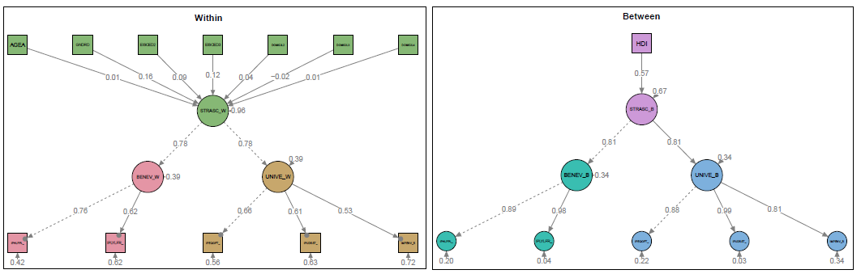

Figure 6: Multilevel Structural Equation model with regressor on second order latent variable, round 8.

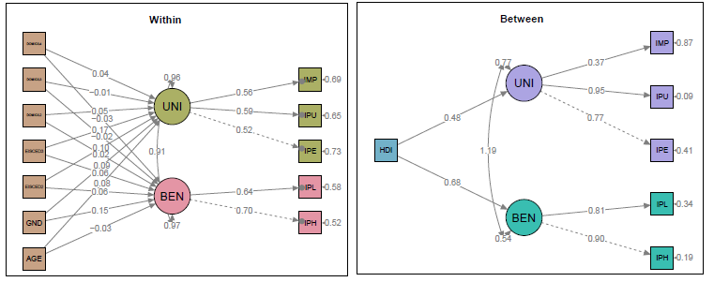

Figure 7: Multilevel MIMIC model with regressors on two latent variables, round 8.

# Results

Confirmatory Factor Analysis (CFA) confirm the relation between the two latent variables Benevolence and Universalism with their respective observed variables. As stated in Figure 2, there is a high association between the two latent variables, Benevolence and Universalism, in both rounds, 0.90-0.93 respectively and all estimates are between 0.52 and 0.71, these values are similar among rounds. Measures of fit in Table 5Table 1 indicates that there is a Good Fit of the model in both rounds of the survey. CFI and TLI values are above the critical value and RMSEA is lower than 0.05.

The measurement model considering two-level CFA also obtain a good fit according to the fit measures in Table 1, standardized factor loadings in the within level (people) are between 0.53 and 0.68, at the between level standardized factor loadings are between 0.77 and 0.96, manifest variable “*Impenv*-*Looking after the environment is important to her/him”* is the exception with low standardized factor loading of 0.27-0.44 in each round for the Universalism latent variable as indicated in Figure 5. This would invalidate the concept of isomorphism in the universalism scale, this would not allow to aggregate constructs measured at the individual level to draw inferences at the country level.

|  |  |  |  |  |  |  |
| --- | --- | --- | --- | --- | --- | --- |
| Methodology | Round | $χ^{2}$ (pvalue) | CFI | TLI | RMSEA | SRMR |
| CFA  (2 lv with correlation) | 8th (2016) | 167.080  (0.000) | 0.993 | 0.987 | 0.034 | 0.068 |
| 9th (2018) | 295.870  (0.000) | 0.988 | 0.975 | 0.046 | 0.105 |
| MLCFA  (two level,  2 lv correlated) | 8th (2016) | 75.369  (0.000) | 0.987 | 0.979 | 0.014 | 0.018 (within)  0.068 (between) |
| 9th (2018) | 125.828  (0.000) | 0.973 | 0.954 | 0.019 | 0.021 (within)  0.065 (between) |

Table 1: Measurement models fit measures

Due to the complexity of the data, is not possible to have a naturally full metric equivalence, free inequivalent parameters was necessary, after exclude intercepts for “*iplylfr-She/he wants to devote herself/himself to people close to her/him.”* and “*ipeqopt-* *She/he believes everyone should have equal opportunities in life”,* partial invariance was accomplished with deltas < 0.03 as indicated in Table 2. This critical value is debatable to be considered as a good fit of partial scalar invariance, but freely more parameters would not be recommended, for this reason, a next step should be done in order to confirm if these results are correct.

From individual models by countries is possible to identify 2 different groups of countries regarding their standardized factor loadings at each manifest variable, these groups are:

* Group 1: Austria, France, Ireland, Italy, Slovenia, and United Kingdom with factor loadings around 0.7 for Benevolence scale and 0.6 for Universalism.
* Group 2: Belgium, Czechia, Estonia, Germany, Netherlands, Norway, Poland, and Switzerland with factor loadings around 0.6 for Benevolence scale and 0.5 for Universalism.

|  |  |  |  |  |  |  |  |  |
| --- | --- | --- | --- | --- | --- | --- | --- | --- |
| Round | 8th (2016) | | | | 9th (2018) | | | |
| Invariance | Cfi | Rmsea | Cfi  delta | Rmsea  delta | Cfi | Rmsea | Cfi  delta | Rmsea  delta |
| Configural | 0.983 | 0.046 |  |  | 0.980 | 0.052 |  |  |
| Metric | 0.976 | 0.043 | 0.007 | 0.003 | 0.970 | 0.051 | 0.010 | 0.001 |
| Scalar | 0.917 | 0.074 | 0.059 | 0.031 | 0.911 | 0.080 | 0.059 | 0.029 |
| Partial scalar | 0.942 | 0.064 | 0.034 | 0.021 | 0.941 | 0.067 | 0.029 | 0.016 |
| Strict | 0.882 | 0.080 | 0.035 | 0.006 | 0.879 | 0.084 | 0.032 | 0.004 |
| Partial Strict | 0.907 | 0.074 | 0.035 | 0.010 | 0.910 | 0.074 | 0.031 | 0.007 |

Table 2: Invariance measures CFA (1 level)

For models considering covariates, fit measures are available in Table 3. These measures indicate that one level models (SEM, MIMIC) present CFI and TLI values above the critical values (> 0.90), and lower than critical values for RMSEA and SRMR (<0.05) in both rounds studied. On the other hand, in models considering country level (MLSEM, MLMIMIC) only RMSEA fit measure present values below the critical point, CFI and TLI are below 0.90 in most cases, SRMR for within level is below the critical value, this cannot be said for between level. For MLMIMIC model only CFI value has a good value.

|  |  |  |  |  |  |  |
| --- | --- | --- | --- | --- | --- | --- |
| Methodology | Round | $χ^{2}$ (pvalue) | CFI | TLI | RMSEA | SRMR |
| SEM  (2nd order LV, two LV and covariates) | 8th (2016) | 514.182  (0.000) | 0.900 | 0.866 | 0.022 | 0.037 |
| 9th (2018) | 579.133  (0.000) | 0.948 | 0.930 | 0.023 | 0.038 |
| MIMIC  (Two LV correlated with covariates) | 8th (2016) | 233.994  (0.000) | 0.957 | 0.923 | 0.016 | 0.021 |
| 9th (2018) | 241.930  (0.000) | 0.980 | 0.963 | 0.017 | 0.018 |
| MLSEM  (Two level,  2nd order LV with covariates) | 8th (2016) | 1163.872  (0.000) | 0.845 | 0.814 | 0.028 | 0.036 (within)  0.255 (between) |
| 9th (2018) | 832.964  (0.000) | 0.889 | 0.859 | 0.025 | 0.020 (within)  0.205 (between) |
| MLMIMIC  (Two levels, two LV correlated with covariates) | 8th (2016) | 541.859  (0.000) | 0.929 | 0.867 | 0.024 | 0.021 (within)  0.122 (between) |
| 9th (2018) | 579.377  (0.000) | 0.923 | 0.855 | 0.025 | 0.018 (within)  0.088 (between) |

Table 3: Structural models fit measures

Factor loadings for manifest variables in SEM model are around 0.51 and 0.83 as stated in Figure 3, factor loadings for 2nd order latent variable are around 0.84 and 0.78, same results in both rounds studied. In MIMIC model with 2 latent variables (Figure 4), the factor loadings are a little lower than the previous model, around 0.52 and 0.72, the correlation among both latent variables is around 0.9 in both rounds.

Multilevel SEM (Figure 6) standardized factor loadings are likewise around 0.53 and 0.76 in the within level with factor loadings to the 2nd order latent variable of 0.78 and 0.78 for round 8. Slightly different results are obtained for round 9, where factor loadings are lower than the previous model, around 0.5 and 0.68, with higher factor loading to the 2nd order latent variable of 0.95 and 0.97. In the between level, factor loadings are higher than previous models around 0.81 and 0.99 and to the 2nd order latent variable of 0.81 and 0.81 in both rounds studied.

Finally, in Multilevel MIMIC (Figure 7), standardized factor loadings for exogenous variables are around 0.49 and 0.70 in the within level and correlation among latent variables is around 0.92 in both rounds. For between level, standardized factor loadings are higher again, around 0.77 and 0.95 with the exception of “*Impenv*-*Looking after the environment is important to her/him”* with 0.37 for both rounds. Correlation among the two latent variables is closer to 1.

As mentioned at the beginning of this document, **Self-Transcendence** dimension consider human values like Benevolence and Universalism, this dimension has a focus in the righteous behaviour of a person. According to this research results in Figure 8, for Females is more likely to get higher values in the scale compared to men, this behaviour is harmonious between the last two round of the survey, both methodologies are consistent in the direction and strength of the relation. Opposite, age is not a characteristic that could affect the development of the dimension in the last two rounds, this is indicated by both methodologies.

Educational level is divided into three categories, the ones included in the model indicate a positive relationship with the scale, this means that a person with at least upper secondary or vocational educational level will obtain higher values in the scale compared to people with less than upper secondary educational level, SEM methodology doesn’t found this relation in round 9. But higher relation is for people with a bachelor’s degree or higher compared to people with less than upper secondary educational level. Same results are obtained with both methodologies.

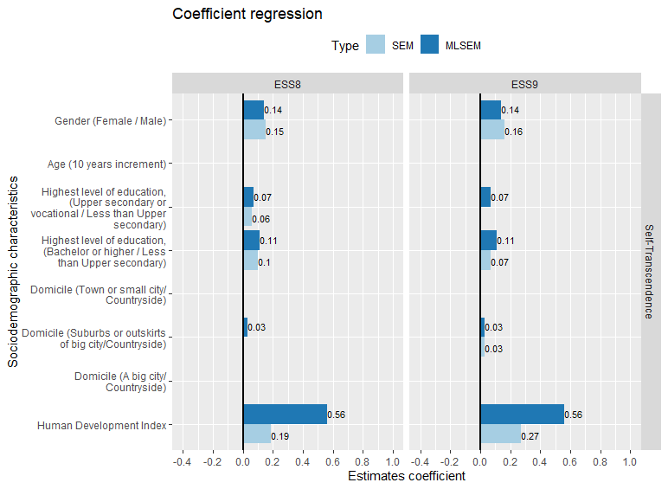

Figure 8: Estimates for regressors on Self-Transcendence with (MLSEM) and without (SEM) Multilevel modelling

Domicile of the person who lived in the Suburbs or Outskirt of a big city present higher values in the scale compare to people from a farm or home in the countryside, this was stated by MLSEM model in both rounds. People from a big city, town or small city or country village did not show difference compare to people from a farm or home in countryside.

Finally, people from countries with a higher human development index also obtained a higher value in the scale of Self-Transcendence, this result has been consistent among both rounds and was identify by both methodologies used. As this variable is from level 2 MLSEM model shows the best estimation which is quite bigger than the estimation from SEM model.

From these aggregated results, it is not clear if estimates could be different considering the subscale separately, Figure 9 shows these estimates by each subscale, Benevolence and Universalism. Gender affects both subscales similarly with both methodologies and in both rounds, this is consistent with the Self-Transcendence scale results. In contrast, The Age variable appears now as significant but with different sign. In Benevolence scale Age is identified with negative effect in both rounds with Multilevel MIMIC analysis and just in 9th round with one-level MIMIC. In Universalism subscale, only one-level MIMIC found a positive relation in 8th round.

The educational level in Benevolence has a weaker effect than in Universalism. In Benevolence only Multilevel MIMIC shows the relation for both categorical variables in both years, one-level MIMIC only in 8th round. As said before, in Universalism subscale the effects are higher and both models found similar relations in both rounds. Domicile of the person is an interesting variable as the results indicate that the location where people live is not related to Benevolence at all. Different is the case for Universalism where people that lived in a town or small city showed small effect with the MIMIC model in 8th round compared to people from a Farm or home in the countryside. Consistent to Self-Transcendence scale people from Suburbs or outskirts has higher values in the scale than people from a Farm or home in the countryside. Last variable, Human development index estimates are higher in both rounds with Multilevel MIMIC in both subscales, but with MIMIC this relation is not identified in 8th round for Universalism.

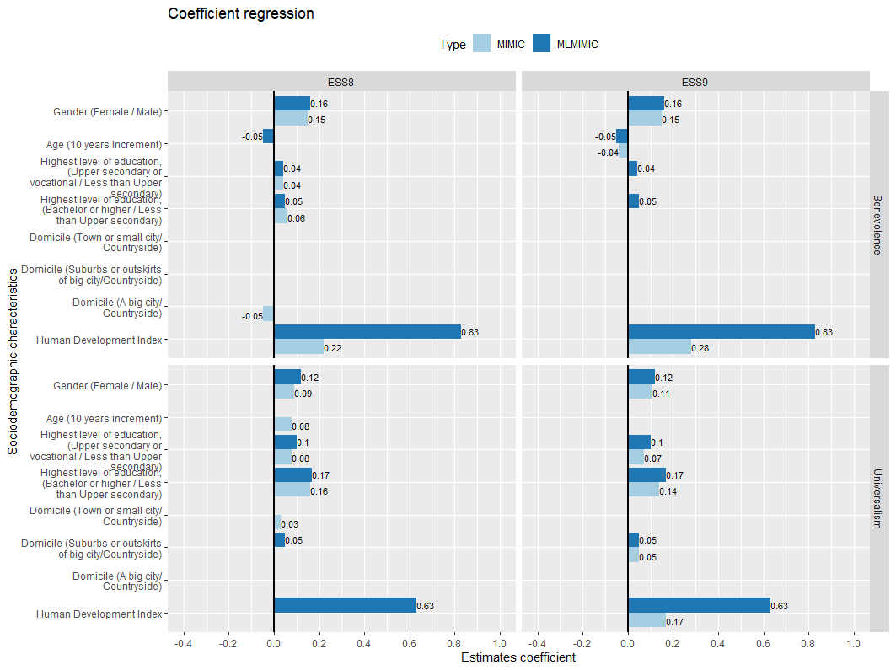

Figure 9: Estimates for regressors on Benevolence and Universalism with (MLMIMIC) and without (MIMIC) Multilevel modelling

In conclusion, according to the theory, results confirm some of the factors that should affect a person’s human values regarding the benevolence and universalism separately and as a aggregated Self-Transcendence. Age seems to be a variable that is not going to be a significant factor for this scale in a short period of time. Regarding the methodologies used, multilevel structural equation modelling is more effective in trying to use clustered information from the data and clustered (national) covariates, considering correctly the differences produced by cross-national surveys, although a specific structural model for level 2 should be studied in order to improve the fit. And depending on the number of latent variables to study, MIMIC models are more efficient when we want to analyse subscales rather than dimensions as it still considers all information. If aggregated results wants to be obtained, a second-order model will help to accomplish this considering both subscales as one.

# REFERENCES

Brown, Timothy A. 2006. *Confirmatory Factor Analysis for Applied Research*. Methodology in the Social Sciences. New York: Guilford Press.

Coleman, James S. 1990. *Foundations of Social Theory*. Cambridge: Belknap press of Harvard university press.

Daniel Oberski. 2016. ‘Complex Survey Structural Equation Modeling (SEM) Package “Lavaan.Survey”’.

Davidov, Eldad, Hermann Dülmer, Elmar Schlüter, Peter Schmidt, and Bart Meuleman. 2012. ‘Using a Multilevel Structural Equation Modeling Approach to Explain Cross-Cultural Measurement Noninvariance’. *Journal of Cross-Cultural Psychology* 43 (4): 558–75. https://doi.org/10.1177/0022022112438397.

Davidov, Eldad, Bart Meuleman, Jan Cieciuch, Peter Schmidt, and Jaak Billiet. 2014. ‘Measurement Equivalence in Cross-National Research’. *Annual Review of Sociology* 40 (1): 55–75. https://doi.org/10.1146/annurev-soc-071913-043137.

European Social Survey. 2018. ‘ESS-9 2018 Documentation Report. Edition 1.2.’ Bergen, European Social Survey Data Archive, NSD - Norwegian Centre for Research Data for ESS ERIC.

European Social Survey Round 8 Data. 2016. ‘Data File Edition 2.1.’ NSD - Norwegian Centre for Research Data, Norway - Data Archive and distributor of ESS data for ESS ERIC.

European Social Survey Round 9 Data. 2018. ‘Data File Edition 1.2.’ NSD - Norwegian Centre for Research Data, Norway - Data Archive and distributor of ESS data for ESS ERIC.

Glen, N. D. 1974. ‘Aging and Conservatism’. *Annals of the American Academy of Political and Social Science* 415: 176–86.

Inglehart, R. n.d. ‘Modernization and Postmodernization: Cultural, Economic and Political Change in 43 Countries.’ Princeton University Press.

Inglehart, Ronald. 1997. *Modernization and Postmodernization : Cultural, Economic, and Political Change in 43 Societies*. Princeton (N.J.): Princeton university press.

Kohn, Melvin L., and Carmi Schooler. 1983. *Work and Personality: An Inquiry into the Impact of Social Stratification*. Modern Sociology. Norwood, N.J: Ablex Pub. Corp.

Meuleman, Bart. 2019. ‘Multilevel Structural Equation Modeling for Cross-National Comparative Research’. *KZfSS Kölner Zeitschrift Für Soziologie Und Sozialpsychologie* 71 (1): 129–55. https://doi.org/10.1007/s11577-019-00605-x.

Prince-Gibson, Eetta, and Shalom H. Schwartz. 1998. ‘Value Priorities and Gender’. *Social Psychology Quarterly* 61 (1): 49. https://doi.org/10.2307/2787057.

Schwartz, S.H. n.d. ‘Basic Human Values: Their Content and Structure across Countries.’ Editora Universidade de Brasilia.

Schwartz, Shalom. 2003. ‘A Proposal for Measuring Value Orientations across Nations’. *Questionnaire Package of ESS*, 259–90.

Schwartz, Shalom, and Klaus Boehnke. 2004. ‘Evaluating the Structure of Human Values with Confirmatory Factor Analysis’. *Journal of Research in Personality* 38: 230–55. https://doi.org/10.1016/S0092-6566(03)00069-2.

Steenkamp, Jan‐Benedict E. M., and Hans Baumgartner. 1998. ‘Assessing Measurement Invariance in Cross‐National Consumer Research’. *Journal of Consumer Research* 25 (1): 78–107. https://doi.org/10.1086/209528.

Veroff, Joseph, David Reuman, and Sheila Feld. 1984. ‘Motives in American Men and Women across the Adult Life Span.’ *Developmental Psychology* 20 (6): 1142–58. https://doi.org/10.1037/0012-1649.20.6.1142.

# AppendiCE

|  |  |  |  |  |  |  |  |  |
| --- | --- | --- | --- | --- | --- | --- | --- | --- |
| **Human values dimensions** | | ***Now I will briefly describe some people. Please listen to each description and tell me how much each person is or is not like you.*** | **Very much like me** | **Like me** | **Somewhat like me** | **A little like me** | **Not like me** | **Not like me at all** |
| Benevolence | Iphlppl | It is very important to her/him to help the people around her/him. She/he wants to care for their well-being. | 1 | 2 | 3 | 4 | 5 | 6 |
| Iplylfr | It is important to her/him to be loyal to her/his friends. She/he wants to devote herself/himself to people close to her/him. | 1 | 2 | 3 | 4 | 5 | 6 |
| Universalism | Ipeqopt | She/he thinks it is important that every person in the world should be treated equally. She/he believes everyone should have equal opportunities in life. | 1 | 2 | 3 | 4 | 5 | 6 |
| Ipudrst | It is important to her/him to listen to people who are different from her/him. Even when she/he disagrees with them, she/he still wants to understand them. | 1 | 2 | 3 | 4 | 5 | 6 |
| Impenv | She/he strongly believes that people should care for nature. Looking after the environment is important to her/him. | 1 | 2 | 3 | 4 | 5 | 6 |

Table 4: Items associated to the latent variable with their response’s categories

|  |  |  |
| --- | --- | --- |
| **Country** | **8th round** | **9th round** |
| Austria | 2010 | 2499 |
| Belgium | 1766 | 1767 |
| Czechia | 2269 | 2398 |
| Estonia | 2019 | 1904 |
| France | 2070 | 2010 |
| Germany | 2852 | 2358 |
| Ireland | 2757 | 2216 |
| Italy | 2626 | 2745 |
| Netherlands | 1681 | 1673 |
| Norway | 1545 | 1406 |
| Poland | 1694 | 1500 |
| Slovenia | 1307 | 1318 |
| Switzerland | 1525 | 1542 |
| United Kingdom | 1959 | 2204 |

Table 5: Sample size by country and round

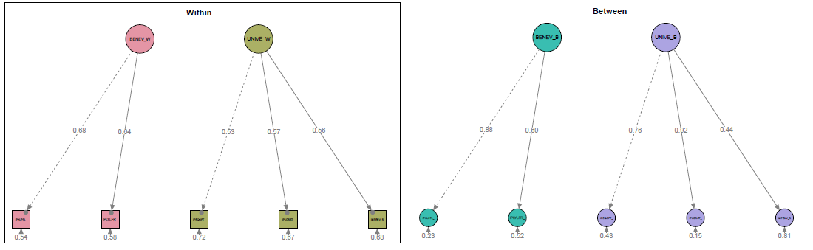

Figure 10: Measurement model using Multilevel modelling, round 9

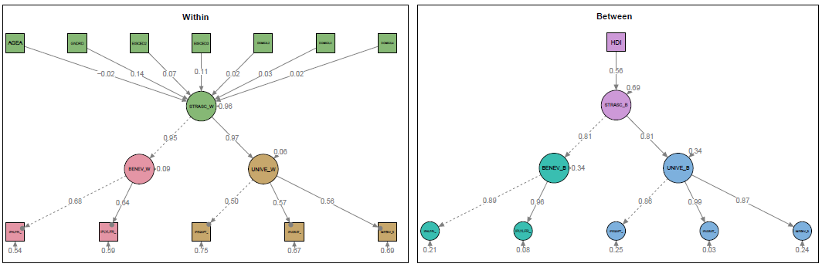

Figure 11: Multilevel Structural Equation model with regressor on second order latent variable, round 9

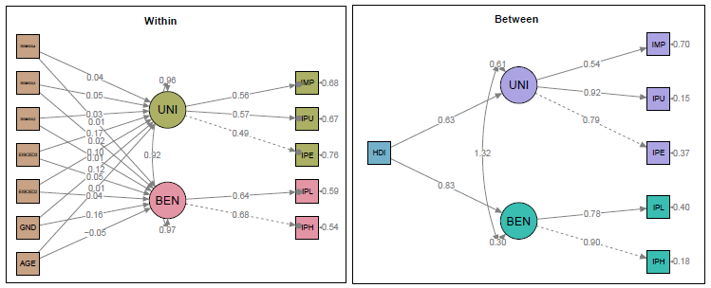

Figure 12: Multilevel MIMIC model with regressors on two latent variables, round 9

1. https://www.europeansocialsurvey.org/data/
2. <http://hdr.undp.org/en/data>
3. Diagrams for 9th round can be found in the Appendix.